

PG Primary ITaP Booklet
ITaP 4: Attachment and Trauma-Informed Practice
Monday 19th April to Friday 23rd April 2027
ITaP Lead: Lizzie Yeomans

Introduction to ITaPs

What is an ITaP?
Intensive Training and Practice (ITaP) is a core part of your Initial Teacher Education (ITE) programme at Liverpool John Moores University. ITaPs are carefully designed training experiences that enable you to focus closely on specific aspects of teaching and learning, helping you to develop important professional knowledge, skills and understanding through a structured cycle of learning and practice. Unlike broader school placement experiences, ITaPs provide dedicated opportunities to explore particular areas of teaching in depth. They connect educational research, theory, expert practice, rehearsal, classroom application and reflection, allowing you to build confidence and competence in key areas of the ITTECF and LJMU Primary Curriculum.

Full engagement in all ITaP activities, documentation requirements and assessment tasks is a mandatory component of your programme and is expected as part of the professional responsibilities of all LJMU student teachers.

Key Features of ITaPs at LJMU
At LJMU, ITaPs are designed using the Grossman (2018) model, which provides a structured and evidence-informed approach to developing professional practice. Each ITaP week is organised around five interconnected stages that support deep learning and meaningful application of theory to practice.

Together, these five stages provide a purposeful and coherent learning journey that supports the development of effective teaching practice.

Monitoring the Impact of ITaPs
Monitoring and evaluating the impact of ITaPs is an important part of ensuring the quality of your learning and maintaining compliance with programme expectations.

Throughout each ITaP, you will be expected to engage fully with all activities, maintain appropriate records and evidence and complete any required reflections or assessments. Your progress will be reviewed through a range of mechanisms, including mentor feedback, observations, professional discussions, portfolio evidence and self-reflection.

By evidencing your participation and learning at each stage of the ITaP process, you will demonstrate how your knowledge and practice have developed. This ensures that ITaPs contribute meaningfully to your progress, support your readiness for placement experiences and provide clear evidence of your developing competence against the Phase Expectations.

Embedding the Learning from ITaPs
You are expected to apply and embed learning from each ITaP within the school placement that follows. ITaPs are designed to develop specific aspects of teaching practice and their impact is strengthened when this learning is transferred into everyday classroom teaching. You should make explicit links between their ITaP experiences and their planning, teaching, assessment and professional decision-making. Evidence of this ongoing development will be reviewed through weekly mentor meetings, university tutorials, lesson observations, professional discussions and placement assessments. Demonstrating how ITaP learning informs practice is an important aspect of professional responsibility and programme compliance.

Roles and Responsibilities During ITaPs
Student Teacher
ITaPs provide an opportunity to develop a rich and detailed understanding of a specific aspect of teaching and learning. As a result, attendance, participation and engagement in all ITaP activities are mandatory and form part of the requirements of the programme.

Student teachers are expected to take ownership of their professional learning by preparing fully for each ITaP and engaging actively with all associated activities. Before the ITaP begins, student teachers should familiarise themselves with the programme materials and discuss opportunities with their mentor to observe, practise and apply the focus of the ITaP within the classroom.

Throughout the ITaP, student teachers should:
- Attend and engage fully with all university and school-based activities.
- Complete all required reading, preparation, reflection and assessment tasks.
- Use the provided documentation and resources to record their learning.
- Engage professionally with mentors, lecturers and peers.
- Reflect critically on the relationship between theory, research and practice.
- Apply and subsequently embed learning from the ITaP during school placements.

Mentor
Mentors play a crucial role in supporting student teachers to engage meaningfully with the ITaP process and connect their learning to classroom practice. Mentors should ensure they are familiar with the purpose, structure and focus of each ITaP and engage with any associated mentor development activities.

Mentors are expected to:
- Support student teachers' participation in all ITaP activities.
- Ensure sufficient opportunities are available for observation, professional discussion, rehearsal and teaching linked to the ITaP focus.
- Facilitate professional conversations that help student teachers analyse and reflect upon practice.
- Provide feedback on the student teacher's development and application of learning.
- Support the student teacher in identifying opportunities to embed ITaP learning within subsequent placement experiences.
- Contribute to monitoring progress through regular mentor meetings and placement assessment processes.

University Staff
University staff (Lead Mentors and Lecturers) work in partnership with schools to ensure ITaPs provide a high-quality, evidence-informed learning experience. They support student teachers and mentors in making meaningful connections between research, theory and classroom practice.

University staff are responsible for:
- Designing and delivering ITaP learning experiences and associated resources.
- Facilitating lectures, seminars, workshops, tutorials and collaborative learning opportunities.
- Supporting student teachers in linking theory, research and practice.
- Providing guidance and support to mentors throughout the ITaP process.
- Monitoring student engagement, participation and progress.
- Quality assuring the implementation and impact of ITaPs through tutorials, placement visits, professional discussions and assessment activities.
- Evaluating the effectiveness of ITaPs to ensure they continue to support trainee development and programme compliance.

Successful ITaPs rely on a strong partnership between student teachers, mentors and university staff, with each stakeholder playing an important role in supporting professional learning and development.

Rationale for ITaP Focus

Why is Trauma Informed Practice an ITAP focus?

The ACEs study (Felitti et al., 1998) found that adverse childhood experiences – experiences that cause childhood trauma – are a leading determinant of the most common forms of physical illness, mental illness, and early death in the Western World. Further research (Bellis et al., 2017; Hornstein and Eisenberger 2017) found that these adverse effects can be mediated by the presence of one emotionally available adult, or always available adult, in the child’s life before the age of 18. Trauma informed practice centres around approaches that enable professionals, including teachers, to provide emotional availability that can support the needs of pupils who have suffered trauma, in a way that is appropriate and achievable in the school environment (Venet, 2019). This is important because unresolved trauma has repeatedly been found to be a blocker of academic development as well as emotional development, and therefore presents a known barrier to children’s learning and feelings of safety (Carrion and Wong, 2012; Golding, Phillips and Bomber, 2020).
By focusing on trauma informed practice in an ITAP, we can navigate what can be quite complex psychological theories into evidence-based, accessible strategies that student teachers can enact in their own practice.

What constitutes ‘best practice’ in Trauma Informed Practice?

Why we have chosen PACE:
PACE is an approach developed as part of Dan Hughes’s Dyadic Developmental Practice (Hughes 2004, Hughes 2012). Initially used in clinical practice with parents supporting children’s attachment difficulties, it has more recently been developed to use in schools as part of trauma informed practice (Golding, Phillips and Bomber, 2020). PACE is an approach relating to all individuals within the school that can support the emotional availability and relational practice that is central to a trauma informed approach. As it is an individual approach, it is not entirely reliant on systematic school-wide approaches and so is a meaningful way in which our student teachers can use trauma informed practice in their placement settings, as it is something they can do with all students – and colleagues – all the time.

SEND in this ITaP
The intensive nature of ITAP provides an opportunity to deepen student teachers’ understanding and practice of pivotal elements of teaching and to consider how these can be used successfully with all pupils, including those with SEND.
Within this ITaP, a SEND lens is woven throughout the training cycle, enabling student teachers to consider how attachment-aware, trauma-informed and adaptive approaches can remove barriers to learning and participation. Student teachers are encouraged to focus closely on individual pupils, examining how strategies such as relationship-building, emotional regulation, scaffolding, modelling and the use of PACE can be adapted to meet diverse needs. Through engagement with research, expert modelling, deliberate practice, observation and feedback, student teachers develop a nuanced understanding of how inclusive classroom practice can support pupils with SEND to feel safe, valued, engaged and ready to learn. This emphasis on adapting teaching to individual needs ensures that SEND is not treated as a separate consideration, but as an integral aspect of effective teaching throughout the ITAP process.

Overview of the Week
Day 1 Notes on sessions

Day 1 case study workshop

For each case study, think about:
What emotions the child may be feeling? Why?

What might be happening to their nervous system (Fight, Flight, Freeze, Fawn)?

What aspect/s of PACE could help them?

What could you try?

These two resources What about Me? (below) and What Survival Looks like in the Primary School (see Canvas) will help you to choose a suitable trauma informed response.

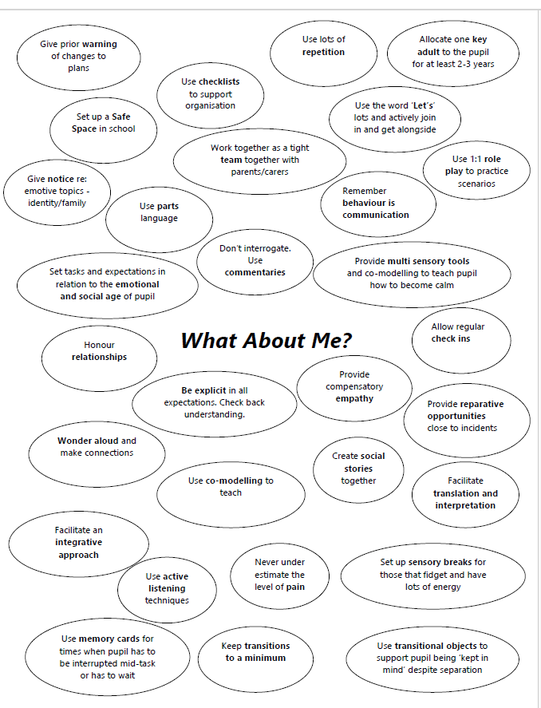

Day 1: key takeaways and reflective notes
Day 2 pre-reading and video: space for notes

Venet, A. S. (2019). Role-clarity and boundaries for trauma-informed teachers. Educational Considerations, 44(2), 3.

How the Body Keeps the Score on Trauma: https://www.youtube.com/watch?v=iTefkqYQz8g

School-based task 1: Brain soother plan

Brain breaks/ Brain soothers
Please ensure that you discuss your two choices with your mentor. Make amendments if needed.

Description of brain soother chosen | Reason for choosing this brain soother | Resources needed | Timings of the day when you want to introduce the brain soother | Mentor sign off
1.

2.

Brain-soothers: Reflection on delivery in school and any photos (not of pupils) for Friday’s presentations
Feedback from teacher on brain-soothers

School based task 1 2 brain breaks/ soothers
To do | Comments | Signed by mentor
Planned 2 brain breaks/ soothers. Discussed with the mentor prior to the day. Completed.

End of day discussion with mentor.

Student teacher reflection – please fill in the ‘comments’ column on this form.

School-based task 2: belonging lesson plan (upload a mind map and lesson plan)

You will need to plan a whole lesson, with the end result being a display or photos of the activity. Make sure you have planned opportunities for autonomy, relatedness and competence to build intrinsic motivation (Ryan and Deci, 2020).

LO: To help pupils to feel a sense of belonging in the class through a PACE approach.

Feedback from teacher on school-based task 2
Lesson on belonging with a PACE approach (playful, accepting, curious, empathy)
To do | Comments | Signed by mentor
Planned lesson reflecting aspects of PACE with a focus on belonging. Discussed with the mentor prior to the day. Completed.

Post -lesson discussion with mentor.

Student teacher reflections – please fill in the ‘comments’ column on this form.

Preparation for Day 5: Notes for Friday’s session – you will be creating a poster/ presentation on the school-based tasks– try to make connections with readings and think about how you can communicate the impact the school-based tasks had on you and your pupils.

Day 5: Reflection

Summarise the main messages from your presentation

What did you learn from watching others’ presentations? Any new learning or new connections?

Learning Outcomes
•To understand and accept that some children have experienced trauma and/ or adverse childhood experiences (ACEs)
•To recognise how trauma impacts the learning brain
•To be more equipped to support children in your school and classroom to feel safe and accepted
•To develop playful and curious practice
•To understand and enact the attributes of empathy
•To know your role boundaries and consider own well being

Focus on the PACE approach (playful, accepting, curious, empathy).

End of ITaP Assessment of Progress
General mentors, please use your assessment evidence from this week (e.g. weekly meeting, LAF, planning discussions) to identify the outcomes that the student teacher has demonstrated.
Key learning by the end of the ITaP | Demonstrated | Not yet demonstrated
The student teacher is able to discuss the impact of trauma on the brain and the body.
The student teacher is able to support children in the classroom to feel safe and accepted through strategies such as brain soothers.
The student teacher is able to support children in the classroom to feel safe and accepted through the belonging lesson.
The student teacher is able to define PACE (playfulness, acceptance, curiosity, empathy) and discuss how they developed this in the belonging lesson.
The student teacher has evidence of the brainsoothers (task 1) ready to explain the impact of the ITAP on their classroom back at university.
The student teacher has evidence of the belonging lesson (task 2) ready to explain the impact of the ITAP on their classroom back at university.
The student teacher recognises teacher -pupil role boundaries and considers their own wellbeing.

Please use the outcomes above to identify two targets for the student teacher to prioritise during block placement
Target 1

Target 2

Reading List

Key Reading

Brummer, J. & Thorsborne, M. (2024). Becoming a trauma-informed restorative educator: practical skills to change culture and behavior. Jessica Kingsley Publishers.

Hughes, D. (2012), Brain-based Parenting: The Neuroscience of Caregiving for Healthy Attachment, New York: W.W.Norton
Van Der Kolk, B. (2015) The Body Keeps the Score, Mind, Brain and Body in the Transformation of Trauma, Penguin, Random House, UK.
Venet, A. S. (2019). Role-clarity and boundaries for trauma-informed teachers. Educational Considerations, 44(2), 3.

Further Reading

Bellis, MA. Hardcastle, K. Ford, K. Hughes, K. Ashton, K. Quigg, Z. Butler, N. (2017). Does continuous trusted adult support in childhood impart life-course resilience against adverse childhood experiences - a retrospective study on adult health-harming behaviours and mental well-being. BMC Psychiatry. 2017 Mar 23;17(1):110. doi: 10.1186/s12888-017-1260-z. Erratum in: BMC Psychiatry. 2017 Apr 13;17(1):140. doi: 10.1186/s12888-017-1305-3. PMID: 28335746; PMCID: PMC5364707.

Carrion, V. G., & Wong, S. S. (2012). Can traumatic stress alter the brain? Understanding the implications of early trauma on brain development and learning. Journal of Adolescent Health, 51(2), S23–S28. https://doi.org/10.1016/j.jadohealth.2012.04.010

Clarke, T. (2020). Children’s wellbeing and their academic achievement: The dangerous discourse of ‘trade-offs’ in education. Theory & Research in Education, 18(3), 263–294. https://doi.org/10.1177/1477878520980197
Culshaw, A., & Bodfield, K. (2024). Trauma-informed education: a case for compassion-focused teaching? Pastoral Care in Education, 1–12. https://doi.org/10.1080/02643944.2024.2318776
Dingwall, N and Sebba, J (2018) Evaluation of the attachment aware schools programme: final report. Rees Centre, University of Oxford
Felitti, V. J., Anda, R. F., Nordenberg, D., Williamson, D. F., Spitz, A. M., Edwards, V., & Marks, J. S. (1998). Relationship of childhood abuse and household dysfunction to many of the leading causes of death in adults: The adverse childhood experiences (ACE) study. American Journal of Preventive Medicine, 14(4), 245–258. https://doi.org/10.1016/S0749-3797(98)00017-8
Golding, K.S., Phillips, S. and Bomber, L.M. (2020), Working with Relational Trauma in Schools: An Educator’s Guide to Dyadic Developmental Practice. London: Jessica Kingsley Publishers
Gus, L., Rose, J., Gilbert, L., & Kilby, R. (2017). The introduction of emotion coaching as a whole school approach in a primary specialist social emotional and mental health setting: Positive outcomes for all. The Open Family Studies Journal, 9(1), 95–110. https://doi.org/10.2174/ 1874922401709010095
Hornstein EA, Eisenberger NI (2017) Unpacking the buffering effect of social support figures: Social support attenuates fear acquisition. PLoS ONE 12(5): e0175891. https://doi.org/ 10.1371/journal.pone.0175891

Hughes, D. (2004) An attachment-based treatment of maltreated children and young people, Attachment & Human Development, 6:3, 263-278, DOI:
10.1080/14616730412331281539

Maynard, B. R., Farina, A., Dell, N. A., & Kelly, M. S. (2019). Effects of trauma‐informed approaches in schools: A systematic review. Campbell Systematic Review, 15(1-2), n/a. https://doi.org/10.1002/cl2.1018
McIntyre, J., & Abrams, F. (2020). Refugee Education: Theorising Practice in Schools (1st ed.). Routledge. https://doi.org/10.4324/9780429263811
O’Toole, C., & Dobutowitsch, M. (2023). The courage to care: Teacher compassion predicts more positive attitudes toward trauma-informed practice. Journal of Child & Adolescent Trauma, 16(1), 123–133. https://doi.org/10.1007/s40653-022-00486-x
Panksepp, J. (1998), Affective Neuroscience: The Foundations of Human and Animal Emotions, Oxford: Oxford University Press
Porges, S.W. (2017). The Pocket Guide to The Polyvagal Theory: The Transformative Power of Feeling Safe. New York: W.W.Norton & Company.
Rose, J., McGuire-Snieckus, R., Gilbert, L., & McInnes, K. (2019). Attachment aware schools: The impact of a targeted and collaborative intervention. Pastoral Care in Education, 37(2), 162–184. https://doi.org/10.1080/02643944.2019.1625429
Spence, R., Kagan, L., Kljakovic, M., & Bifulco, A. (2021). Understanding trauma in children and young people in the school setting. Educational and Child Psychology, 38(1), 87-98.
Thomas, M. S., Crosby, S., & Vanderhaar, J. (2019). Trauma-informed practices in schools across two decades: An interdisciplinary review of research. Review of Research in Education, 43(1), 422-452.

Quick and accessible resources

Understanding Trauma: Learning Brain vs Survival Brain (You tube video, Jacob Ham, 5 minutes)
NEU3549 Little book of Trauma-informed v4.pdf by Lancashire Violence Reduction Network
https://growing-stronger.org/ Addressing Adverse Childhood Experiences, Liverpool
https://beaconhouse.org.uk/wp-content/uploads/2019/09/The-Three-Rs.pdf
https://growing-stronger.org/ Liverpool ACE’s training
https://www.youtube.com/watch?v=Kx7PCzg0CGE The Hand Model of the Brain
https://www.youtube.com/watch?v=RRMBHQ-Bmk0&t=3s Co-regulation: What It Is and Why it Matters
https://traumainformedlancashire.co.uk/wp-content/uploads/2023/10/Survival-In-Primary-School-2019.pdf
https://www.annafreud.org/resources/under-fives-wellbeing/what-is-attachment/ Helpful PDF on attachment on this page

