

Intensive Training and Practice (ITAP) 1
Behaviour Management

Booklet

What is an ITAP?
At LJMU, our Intensive Training and Practice (ITAP) programme is all about helping student teachers get to grips with the nuts and bolts of effective teaching. It focuses on the really important parts of teaching practice – the bits that make the biggest difference.

We bring together what the research says works, and give student teachers the time and space to try things out, bit by bit. There’s clear input, chances to practise in a supportive setting, and helpful feedback along the way. These sessions take place both at university and in our partner schools, so student teachers can build their knowledge, skills and confidence.

There are four ITAPs planned across the academic year.

- ITAP 1 - Behaviour management

- ITAP 2 – Introduction to assessment

- ITAP 3 – Effective feedback

- ITAP 4 – SEND

What is the purpose of this booklet?
The ITAP booklet is designed to be your step-by-step guide to working effectively through the ITAP programme. It’s used by student teachers and shared with mentors, and it contains all the activities you’ll need to complete along the way.

ITAP 1 - Behaviour Management
The Behaviour Management ITAP is positioned early in the course curriculum, as behaviour is a key concern for student teachers and one of the most significant challenges faced in the profession.

A high quality classroom culture is created through consistent and intentional behaviour management strategies used by teachers. Since this is a broad topic, we have identified foundational areas to focus on, with clear objectives and specific techniques.

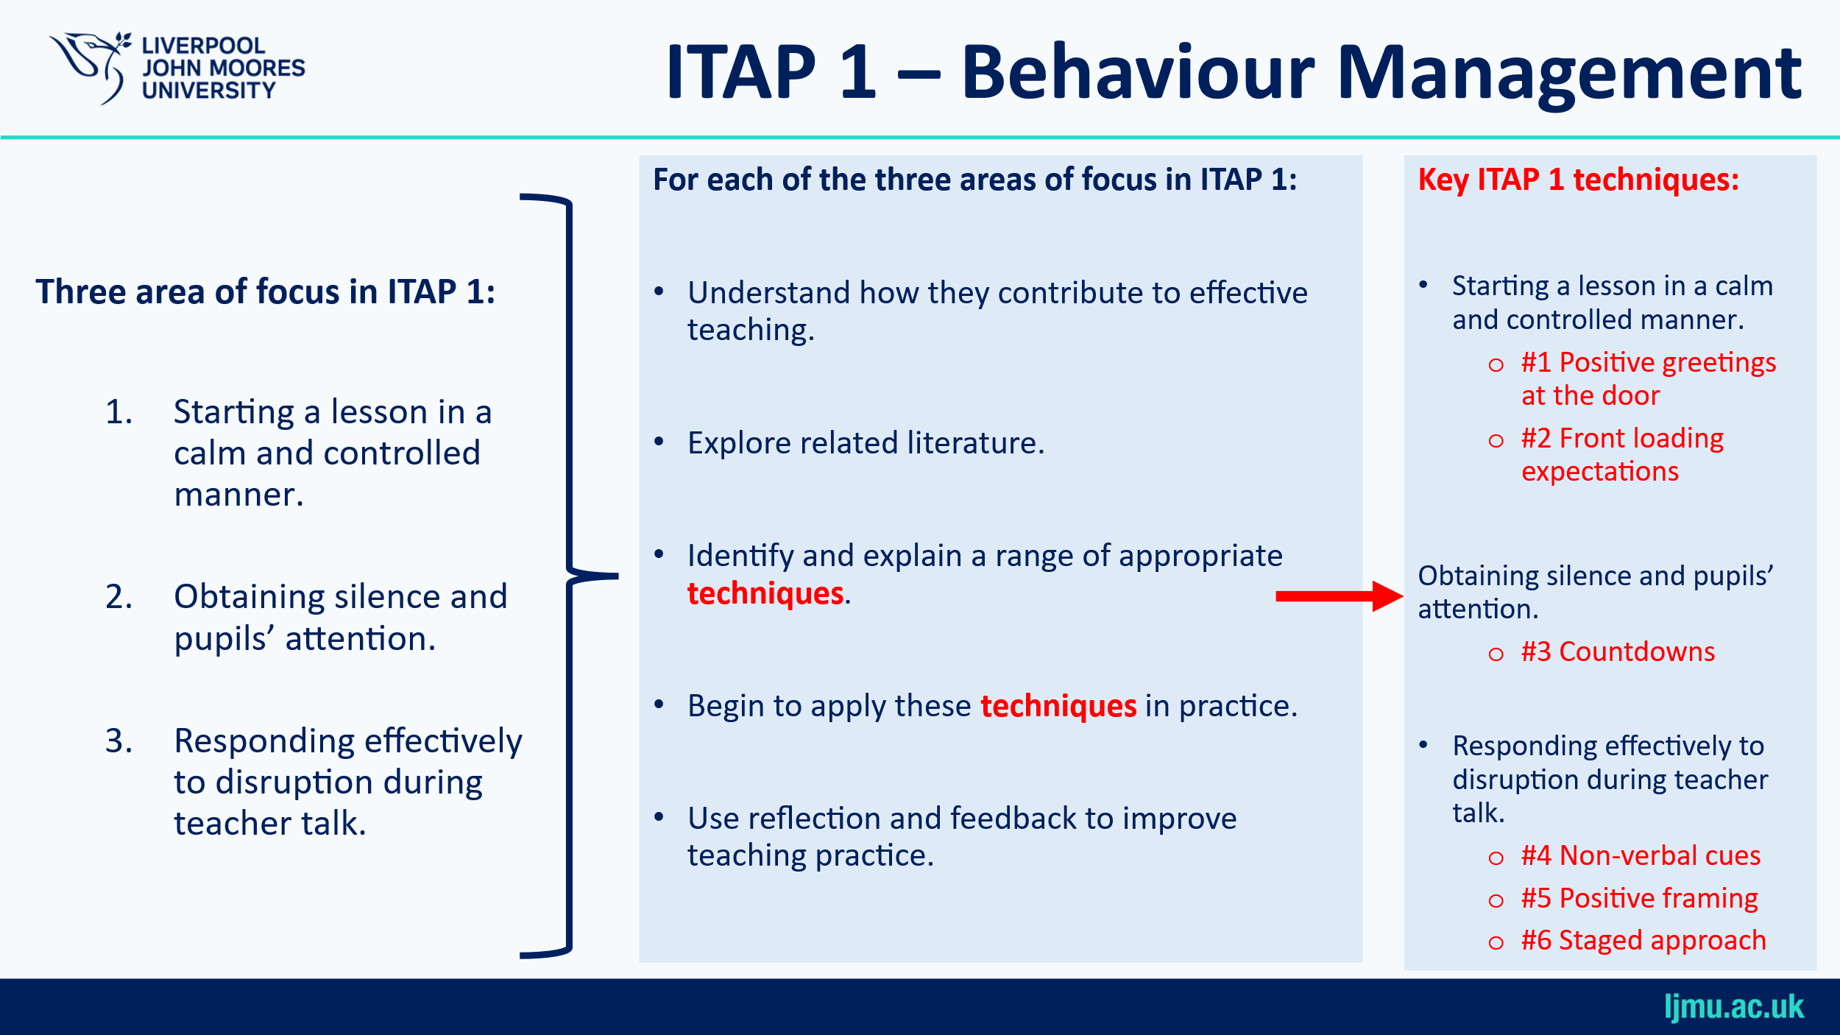

What will the structure of the ITAP look like?

Day |  | Friday  26th September | Monday  29th September | Tuesday  30th September | Wednesday 1st October | Friday  3rd October
Location | NA | University  based | School  based | School  based | School  based | University  based
Activities | - Pre ITAP Activity 1 – essential reading.  - Pre ITAP Activity 2 – case study | - Lead lecture 1  - Workshop 1  - Lead Lecture 2  - Workshop 2 | - Observe three lessons delivered by expert colleagues. | - Plan and deliver three teaching episodes (10 minutes)  - Receive feedback from mentor.  - Reflect on your own teaching episodes. |  | - Lightening talks (5minutes). Deliver your own listen and reflect on others  - Revisit ‘Pre ITAP activity 2 – case study’
To be completed | - Complete Pre ITAP Activity 1  - Complete Pre ITAP Activity 2 | - Complete ITAP activity 1 | - Complete ITAP activity 2 | - Complete ITAP activity 3 |  | - Complete ITAP activity 4  - Complete ITAP activity 5

Pre ITAP Activity 1 – Essential Reading

Read the following texts:

- Bennett, T. (2020). Running the room: The teacher’s guide to behaviour. John Catt.
- Chapter 5 – The culture of the classroom
- Chapter 6 – Establishing useful classroom norms
Available through LJMU electronic library

- Wubbels, T. (2011). An international perspective on classroom management: What should prospective teachers learn?. Teaching Education, 22(2), 113-131.
What does Bennett say about the importance of classroom culture?

How does Bennett describe classroom norms, and how can teachers communicate them clearly and consistently to pupils?

Wubbels identifies six different approaches to classroom management. Based on your reading and any school observations so far, which approach do you think might be most effective in managing behaviour — and why?

Pre ITAP Activity 2– Case study

Context:
You are a student teacher working with a Year 9 class whose behaviour can be particularly challenging. You have been team teaching with your mentor and recently led the starter activity (approximately 10 minutes) at the beginning of a lesson.

After discussing the lesson with your mentor, you've agreed you’re ready to lead your first full lesson with the class. However, you’ve reflected on some behaviour management issues that emerged during the starter, and you want to address these in your next lesson.

Your Reflection from the previous lesson:

- Chaotic Start
  - The beginning of the lesson felt disorganised and lacked clear structure.
  - Pupils were unsure about what was expected of them as they entered.
  - You were focused on managing early disruptions and, as a result, missed greeting other pupils at the door.
  - This led to you feeling out of control right from the start.

- Gaining Silence and Attention
  - Once the starter began, it was difficult to get the class quiet and focused.
  - A pupil named James, in particular, continued to talk after you asked for silence, undermining your authority.
  - Several pupils followed his lead, talking and laughing during your instructions.

- Managing Disruption During Teacher Talk
  - While giving instructions, a number of pupils were calling out or having side conversations. Yasmin appeared keen to engage but frequently shouted out questions during your explanations. Some of these contributions were relevant and thoughtful, while others were off-topic and disrupted the flow of your input
  - This meant many pupils didn’t hear or understand the task, which negatively impacted learning and led to more off-task behaviour.

In the ‘Pre-ITAP Reflections’ section, reflect on the three key behaviour management challenges you identified. Note down some strategies you might use to approach these differently in your next lesson. Do not complete the ‘Post-ITAP Reflections’ section at this stage.
Pre ITAP reflections

Post ITAP reflections

Day 1

ITAP Activity 1 – workshop 1 & 2 tasks

ITAP Workshop 1

Values and classroom culture
- Why are these values important to you?
- Why are they an important foundation for effective behaviour management approaches?

Factors influencing pupil behaviour
- What influences a child’s ability to behave appropriately in secondary school settings?

Teach the behaviour you want
Using the model explore how you might teach pupils the behaviour you want.

Decide
Instruct
Practice
Monitor
(Bennett, 2020)

Video 1
Reflections…

Video 2
Reflections…

Video 3
Reflections…

ITAP Workshop 2 – Observing practice
Video 1
Use this space to make observations on video 1 (PE lesson):

Video 2
What does the teacher do in this Art lesson, and what does it tell you about the class he is teaching?

Video 3
What does the teacher do differently to video 2? Why do you think this is?

Video 4
What does the teacher do in this RE lesson that is similar, and different, to the Art lesson previous?

Signals for Silence
Video 5
What does the teacher do in this Food Tech lesson and how do the pupils respond?

Video 6
What do you notice in this Geography lesson?

Positive Framing & Addressing Pupils
Video 7
What examples of using pupils’ names and positive framing do you see in this Maths lesson and what impact do they have?

Video 8
What do you notice about how the teacher addresses pupils in this English lesson?

Addressing Behaviour
Video 9
What things does the teacher do in response to some poor behaviour in this Art lesson from earlier?

Video 10
In this English lesson from earlier the teacher uses a countdown, it is not followed by some pupils.
How does she handle it, and would you have done anything differently?

Escalation Using Behaviour Policies
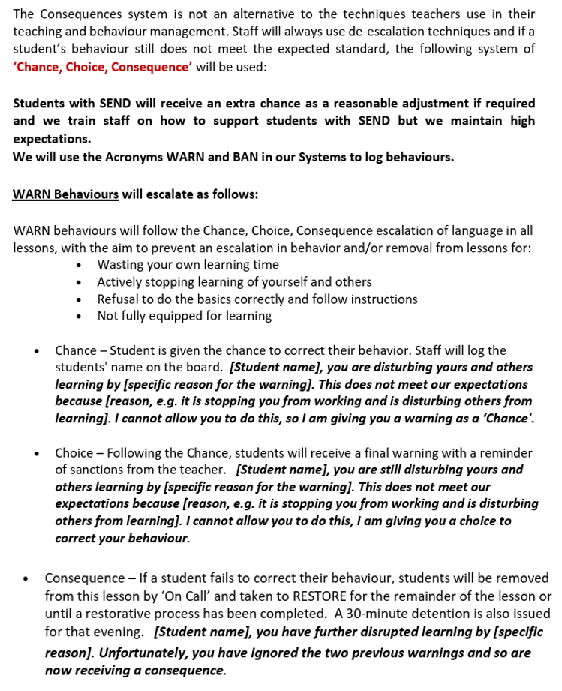
School A School B


How would you respond to the incident shown using each behaviour policy? What are the similarities and differences?

What Happens Next?
Video 11
Focus on what the pupils do after some disruption in this part of the Art lesson from earlier, what would you do next?

Video 12
In this geography lesson what causes the lesson to start in an unsettled manner and what would you do next?

Reflection
- How you have (or haven’t) seen these techniques used on placement already?

- How you would use the techniques more specifically in your school and subject?

- How your own personal style might adapt how they are used, and how you will try to use them moving forward?

Day 2

ITAP Activity 2 – Observing expert colleagues

During Day One of your ITAP, you were introduced to a number of key behaviour management techniques, including:

  - #1 Positive greetings at the door
  - #2 Front loading expectations
  - #3 Countdowns
  - #4 Non-verbal cues
  - #5 Positive framing
  - #6 Staged approach

Today you will observe three different lessons. As you observe the teacher during the lesson look out for these behaviour management techniques — or any others you notice that are effective. Reflect on how they positively influence pupil behaviour, using the table on the following page to record your observations.

Teacher Initials | Practical Strategies for behaviour management, including key techniques covered in ITAP 1. | Effect: The impact on learning that you observed.
Day 3 and 4

ITAP Activity 3 – Teaching, feedback and reflection

Over days 3 and 4 of the ITAP, you will deliver three distinct starter activities to three different classes.

You will have the opportunity to plan each activity, focusing on how to utilise effective behaviour management approaches

Use the planning document provided over the next three pages to plan and reflect on these teaching episodes.

Before delivering each activity, share the planning document with an expert colleague to write their feedback on.

Planning Your 10 minute Teaching Episode
Outline the key concepts you intend to teach and teaching methods you will employ. Focus on behaviour management strategies to gain silence and attention, handle disruption during teacher talk, and start the lesson calmly and in control. Refer to key ITAP techniques like positive greetings at the door, front loading expectations, countdowns, non-verbal cues, positive framing and staged approach.

Expert feedback
This section is for an expert colleague. Please provide your feedback, with particular focus on the behaviour management strategies used during the lesson.

Student teacher reflection
Which parts of the lesson showed positive behaviour? What behaviour challenges did you observe or experience? How effective were the behaviour management techniques used? What would you do differently next time?

Teaching Episode 1
Lesson topic: | Class | Size
Teaching Episode 2
Lesson topic: | Class | Size
Planning Your 10 minute Teaching Episode
Outline the key concepts you intend to teach and teaching methods you will employ. Focus on behaviour management strategies to gain silence and attention, handle disruption during teacher talk, and start the lesson calmly and in control. Refer to key ITAP techniques like positive greetings at the door, front loading expectations, countdowns, non-verbal cues, positive framing and staged approach.

Expert feedback
This section is for an expert colleague. Please provide your feedback, with particular focus on the behaviour management strategies used during the lesson.

Student teacher reflection
Which parts of the lesson showed positive behaviour? What behaviour challenges did you observe or experience? How effective were the behaviour management techniques used? What would you do differently next time?

Teaching Episode 3
Lesson topic: | Class | Size
Planning Your 10 minute Teaching Episode
Outline the key concepts you intend to teach and teaching methods you will employ. Focus on behaviour management strategies to gain silence and attention, handle disruption during teacher talk, and start the lesson calmly and in control. Refer to key ITAP techniques like positive greetings at the door, front loading expectations, countdowns, non-verbal cues, positive framing and staged approach.

Expert feedback
This section is for an expert colleague. Please provide your feedback, with particular focus on the behaviour management strategies used during the lesson.

Student teacher reflection
Which parts of the lesson showed positive behaviour? What behaviour challenges did you observe or experience? How effective were the behaviour management techniques used? What would you do differently next time?

Day 5

ITAP Activity 4 – Lightening talks
You will deliver a short lightning talk to your fellow student teachers. This is not only an opportunity for you to make sense of your own experience and hear from others, but it also helps you develop your practice and presentation skills.

Please follow the instructions below:
- Prepare a 5-minute talk (no longer than 5 minutes). Use the ‘prompt note’s space on the next page.
- No PowerPoint slides – this will be a spoken presentation only.
- You will stand up and present to the group.
What to include in your talk:
- What has been your most important learning about behaviour management during the ITAP?
- Can you describe a specific challenging moment or “critical incident” you observed or experienced?
- How did you handle the situation? Did you use any of the techniques outlined in ITAP 1? Where these effective? How might you alter your approach if faced with this situation again?
- In what ways has this experience shaped how you plan to approach behaviour management when you return to placement?

Whilst listening to other student teachers give their talks, reflect on the following:
- What new insights about behaviour management did you gain?
- How did the speaker handle challenges, and what might you do similarly or differently?
- How were the speaker’s experiences similar to or different from your own?
- What questions would you like to ask the speaker about their experience?

.

Prompt notes for lightening talk

ITAP Activity 5 – Case study re-visited
Revisit ‘Pre-ITAP Activity 2’ on page 7 and complete the Post-ITAP Reflections section. Reflect on the case study and identify any changes you would now make to your original approach, having completed ITAP 1. This task will help you track the development of your knowledge and ideas around behaviour management.

