

Intensive Training and Practice (ITaP) 2
Introduction to Assessment

Booklet

What Is An ITaP?

At LJMU, our Intensive Training and Practice (ITAP) programme is all about helping student teachers get to grips with the nuts and bolts of effective teaching. It focuses on the really important parts of teaching practice – the bits that make the biggest difference.

We bring together what the research says works, and give student teachers the time and space to try things out, step by step. There’s clear input, chances to practise in a supportive setting, and helpful feedback along the way. These sessions take place both at university and in our partner schools, so student teachers can build their knowledge, skills and confidence.

There are four ITAPs planned across the academic year:

- ITaP 1 - Behaviour Management

- ITaP 2 - Assessment

- ITaP 3 - Feedback

- ITaP 4 – SEND

What Is The Purpose Of This Booklet?

The ITAP booklet is designed to be your step-by-step guide to working effectively through the ITAP programme. It’s used by student teachers and shared with mentors, and it contains all the activities you’ll need to complete along the way.

ITAP 2: Assessment

Our Introduction to Assessment is positioned early in the year as all teachers in their planning seek to promote the progression of their pupils, so Assessment is necessary both to help teachers know their pupils’ levels of understanding, and to support such planning for progression.

We are introducing Assessment to you early on, therefore, in association with your planning, overviewing generic aspects of Assessment, with the focus on Formative Assessment in particular, namely Assessment for Learning. You shall be rehearsing and developing four key foundational areas of Formative Assessment, through evidence-based practical strategies informed by theory on: Retrieval Practice; Questioning; Peer and Self- Assessment; and ‘Exit Tickets’. You will discover what these terms mean by way of introduction; observe, analyse and deconstruct expert teaching of such strategies; prepare through models of practice; enact in the classroom; and assess your practice through an intense week of university and school-based engagement.

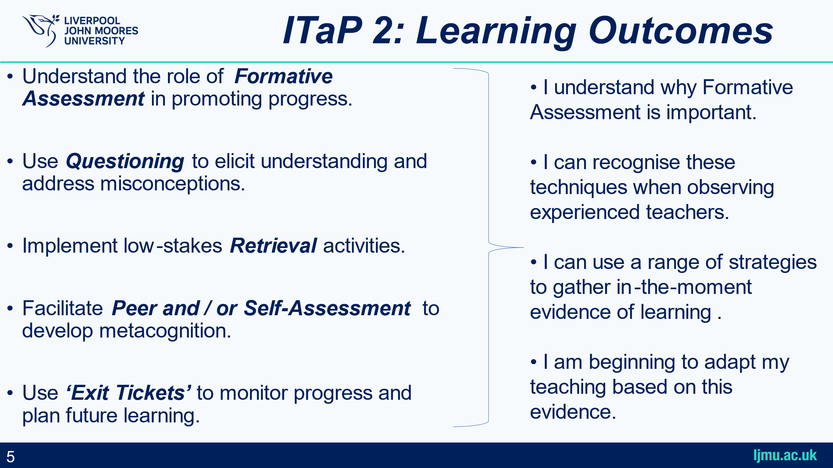

What Will The Structure Of The ITAP Look Like?

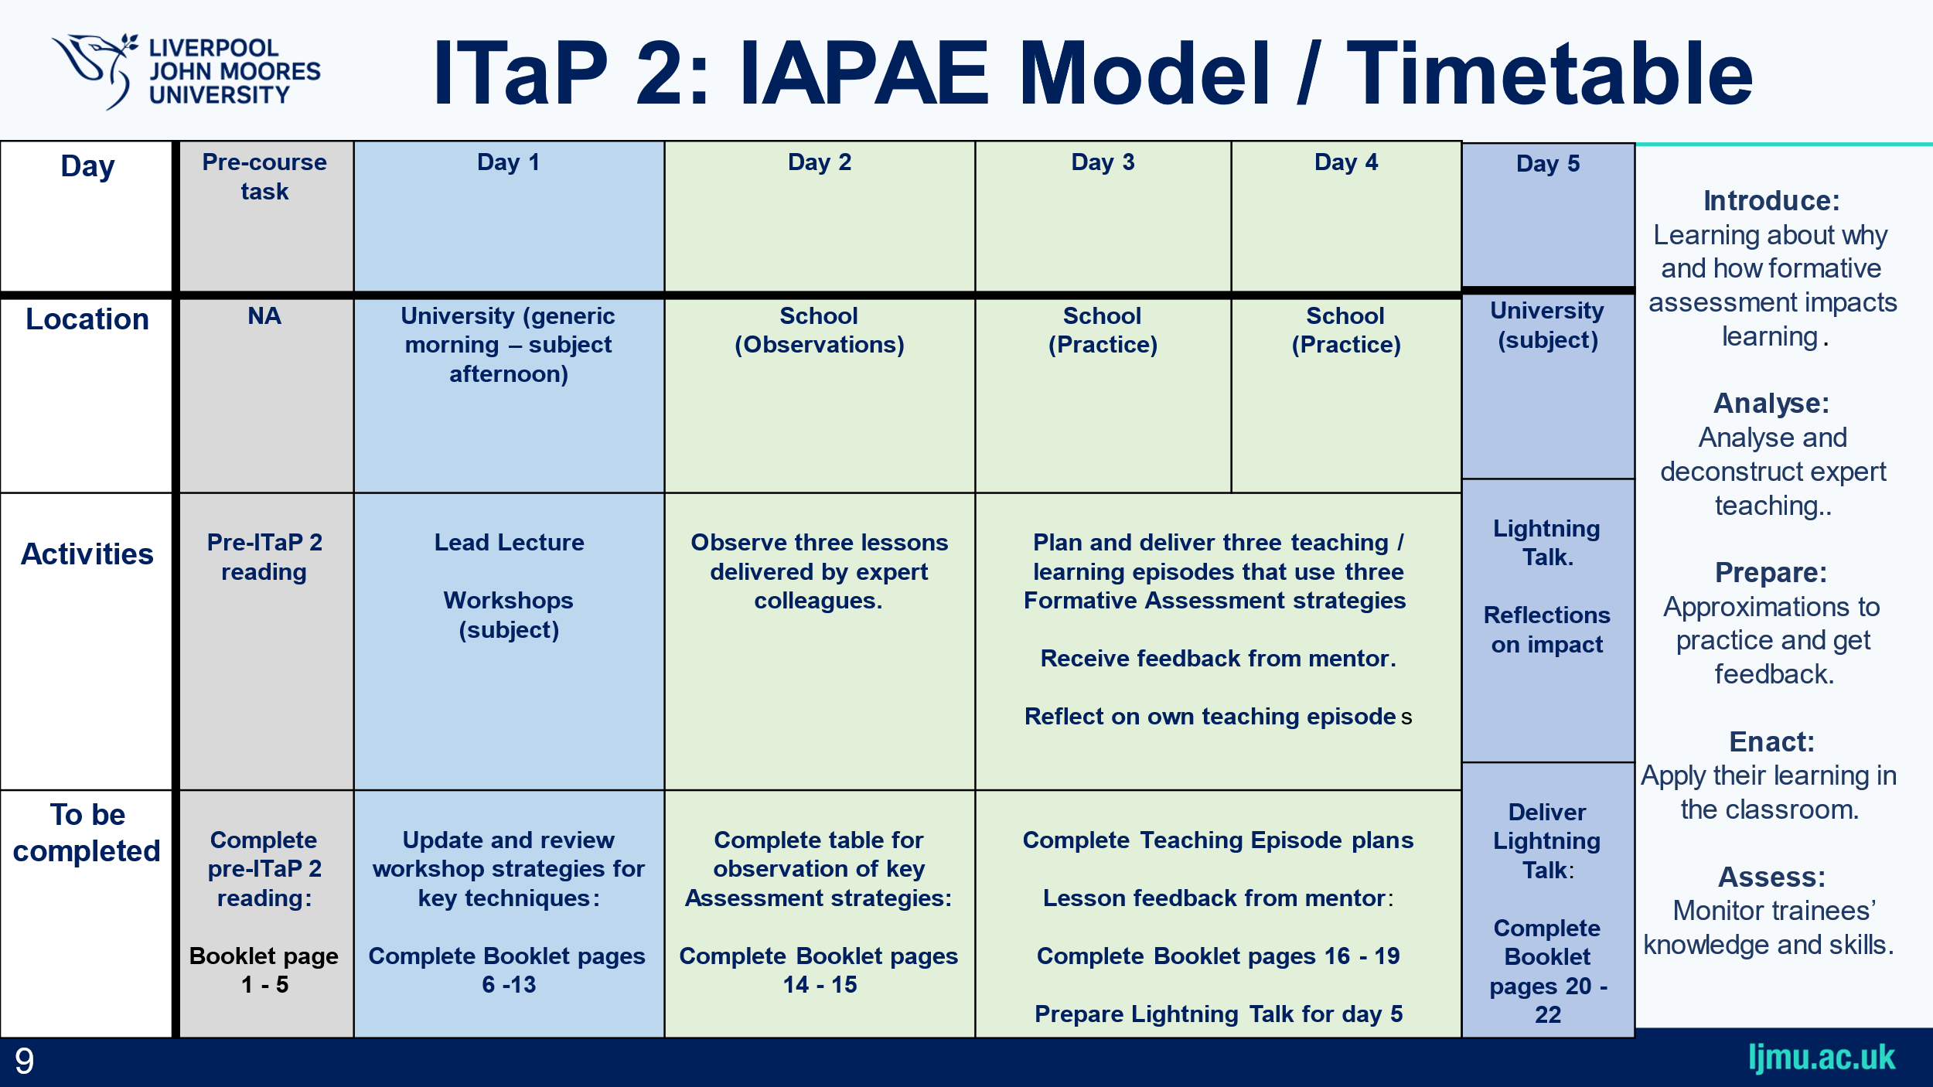
ITaP 2 Essential Pre-Reading

Read the following text online: Dylan Wiliam’s ‘Embedded Formative Assessment’ (2018), Chapter 2. Access here: https://ljmu.primo.exlibrisgroup.com/permalink/44JMU_INST/1vn60f9/alma9911589047703826

- What are your initial thoughts about Formative Assessment following your reading of Dylan Wiliam’s ‘Embedded Formative Assessment’ (2018), Chapter 2?

- What do we mean by Formative Assessment? To what extent are these ideas different from or similar to your experience of assessment as a pupil at school? How and why?

- What three key aspects have you learned from this reading from Wiliam? Have you seen any such ideas in practice at school? What kind of Formative Assessment do you think will prove most effective for your pupils’ learning on school placement? Why is this?

Day 1

ITaP 2 Lecture: ‘Introduce’

The ITaP 2 Lecture will reiterate the objectives of the ITaP; the ITaP 2 week’s timetable; and introduce you to key categories of Assessment with, some interactive engagement, to then focus on Formative Assessment with Assessment for Learning. The Lecture will be placed on the PGCE Community Site under the ITaP heading afterwards, with the Workshop:

ITaP 2 Workshop 1: ‘Introduce’ / ‘Analyse’

The ITaP 2 Workshops in your Subject Studies groups will explore in detail four key strategies of Formative Assessment, like the Lecture, mapped to the ITTEC Framework (DfE 2024) Learn that: 6.1 / 6.4 / 6.5 / 6.6 / 6.7 ; Learn how to: 6.a / e / f / g / h.

- Questioning
- Retrieval
- ‘Exit Tickets’
- Peer and Self-Assessment
Record your response to the central questions on Assessment discussed in the Workshop here below:

Questioning (A):
- What is Cold Calling? What is Directed Questioning?
- What is ‘Think / Write / Speak’?
- How might you use (Mini) White Boards in class?
- How might you ‘Scaffold’ questions?
- Why and How might you ‘Push for Precision’ in Questioning?

Questioning (B):

Response to Doug Lemov’s ‘Teach Like a Champion’ (2021) Chapter 7 Video Clips 76 & 77, then 69:

1) What is the teacher doing to set up Questioning and Response?
2) What specifically is effective about the Questioning here?
3) What aspects of practice here would you challenge?
4) What aspects might you apply on placement?
5) What are the strengths and weaknesses in using such modelling?

Retrieval (A):

- What are ‘Hinge Questions’?
- What is Retrieval?
- What different ways might you ‘Check for Understanding’?

Retrieval (B):

Response to Doug Lemov’s Teach Like A Champion (2021) Chapter 3, Clips 8, 15, and the Retrieval Montage of Clip 10:
1) What specifically is effective about this ‘Checking for Understanding’?
2) What aspects of practice would you challenge?
3) What aspects might you apply on placement?

‘Exit Tickets’ (A):

- What are ‘Exit Tickets’?
- Why use ‘Exit Tickets’?

‘Exit Tickets’ (B): Practice Task:

- What are the qualities of a good ‘Exit Ticket’?
- Analyse Lemov’s guidance for ‘Exit Tickets’.
- Discuss the potential benefits of his guidance.
- Discuss the potential limitations of his guidance.
- How does all this apply to your subject area?

Peer and Self-Assessment (A):

- What is Peer and Self-Assessment?
- Why use Peer and Self-Assessment?

Peer and Self-Assessment (B)

- How could Self-Assessment fit in your subject?
- How will you ‘Scaffold’ criteria for your pupils?
- What will you need to model in advance?

Extension Task: Feedback: Practice Tasks (1/2):

If required and there is time, watch the video clip on ‘Austin’s Butterfly’ and consider:
- How is this feedback given?
- What makes it effective?
- What did you notice about Austin’s response to feedback?
- How was the feedback different from what we often hear…?
- How did the structure and criteria support improvement?
- What does this suggest on how we teach pupils to feedback?

ITaP 2 Workshop 2: ‘Prepare’

Following the ‘Introduction to Assessment’ ITaP 2 Lecture and ‘Formative Assessment Strategies Analysis Workshop’ this morning, we are asking you to pursue in more depth and prepare to use such techniques in our second ITaP 2 Subject Sessions Workshop this afternoon, prior to observation and application through ITaP 2 enactment in school next week. Our focus is now on three of our specific Formative Assessment strategies, Questioning; Retrieval; and ‘Exit Tickets’:

Workshop 2 Session Learning Outcomes: By the end of the session, we anticipate you will be able to:

- Plan and subsequently implement low-stakes Retrieval activities;
- use Questioning to elicit understanding and address misconceptions;
- plan and subsequently use ‘Exit Tickets’ to monitor progress / plan future learning;
- develop a range of such planned strategies for in-the-moment evidence of learning​;
- begin to adapt their teaching based on this evidence / practice.

Planning for Retrieval:

- Plan for a lower school (ideally Year 7) lesson in your subject. You may adapt an existing plan, thinking about a specific class on your particular school placement.

- Incorporate into your original or adapted plan, using the LJMU lesson plan pro-forma, an aspect of Retrieval, utilising what you have learned of effective practice this morning.

- Report back through brief discussion on the context of the lesson envisaged – the Sequence of Learning; the class; individual pupils; time of day; the classroom, etc. - and the Retrieval techniques utilised.

Planning for Questioning:

- When will you be employing Questioning in the lesson? Why?

- Prepare your questions, writing them down, with Follow-Up, to ascertain pupil understanding.

- Report back through brief discussion on the timing and nature of your Questioning.

Planning for ‘Exit Tickets’:

- Design appropriate ‘Exit Tickets’ for your lesson, utilising Lemov from this morning’s ITaP 2 Workshop.

- Report back through brief discussion on the nature of your ‘Exit Tickets’

Recording your Workshop Responses

Make sure you write down your ‘Report Back’ notes and peer and tutor responses in the spaces provided below on each of the strategies planned ie for Retrieval; Questioning; and ‘Exit Tickets’.

Planning for Retrieval ‘Report Back’:

Planning for Questioning ‘Report Back’:

Planning for ‘Exit Tickets’ ‘Report Back’:

Final Workshop Notes, Conclusions and Reminders

Day 2

ITaP 2 Placement Activity 1: ‘Analyse’:

Observing Expert Colleagues:

During Day One of this ITAP at university, you were introduced to a number of key Formative Assessment strategies, including:

- Questioning
- Retrieval
- ‘Exit Tickets’
- Peer and Self-Assessment

Today you will observe three different lessons at your ‘Home’ placement school at the start of this ITaP 2 week.

As you observe the Teacher during the lesson look out for these Formative Assessment strategies — and any other modes of Assessment you notice that are effective. This may include aspects of Feedback which you will explore more deeply for ITaP 3.

Discuss what works with whom with your Mentor and the Classroom Teachers. The conversation may even venture into areas of Summative Assessment but, for now, the focus should be on the four aspects of Formative Assessment listed above. Reflect on how the Assessment strategies observed support both pupil progression and lesson planning.

Complete the table on the following page to record your observations.

In the table below identify the times when effective Formative Assessment was the main activity. Note the strategies the Teacher uses, how often they use them, and to what effect eg in terms of when Questioning / Retrieval / Self and Peer Assessment / and ‘Exit Tickets’ take place; how; and why?

Teacher Initials | Practical Strategies for Formative Assessment: including Questioning / Retrieval / Self / Peer Assessment / ‘Exit Tickets’, et al. | Effect: The Impact on learning that you observed.
Days 3 / 4

ITaP 2: Placement Activity 2: ‘Prepare’, ‘Enact’ and ‘Assess’:

Planning, Teaching, Feedback and Reflection:

Over Days 3 and 4 of this ITAP, you will deliver three distinct Assessment activities to three different classes, using all you have observed and learned at school and university.

You will have the opportunity to plan each activity, focusing on how to utilise effective Formative Assessment, which may include our four key areas of focus, but not necessarily be limited to these:

- Questioning
- Retrieval
- ‘Exit Tickets’
- Peer and Self-Assessment

Use the ITaP planning document provided over the next three pages to plan and reflect on these teaching episodes within the overall Lesson Plan.

Before delivering each activity, share the planning document on the next page with an expert colleague, to discuss, amend, and reflect, asking them to write their feedback on the document itself for your ITaP records, required for completion of the PGCE programme and eventual attainment of Qualified Teacher Status (QTS).

Teaching Episode 1
Lesson Topic: | Class | Size
Lesson Topic:

Planning Your 10 minute Teaching Episode:
Outline the key concepts you intend to teach and teaching methods you will employ. Focus on appropriate Formative Assessment strategies to support pupil progression, thinking about the age and abilities of your individual pupils, the support required, and the logistics of the lesson eg where and when it takes place. Refer to key ITAP 2 techniques discussed and how the episode fits with the planned lesson as a whole.

Expert Feedback:
This section is for an expert colleague. Please provide feedback, with particular focus on the Formative Assessment strategies adopted.

Student Teacher Reflection:
How effective was your Formative Assessment strategy here? What went well? What would you do differently next time, and why?

Teaching Episode 2
Lesson Topic: | Class | Size
Lesson Topic:

Planning Your 10 minute Teaching Episode:
Outline the key concepts you intend to teach and teaching methods you will employ. Focus on appropriate Formative Assessment strategies to support pupil progression, thinking about the age and abilities of your individual pupils, the support required, and the logistics of the lesson eg where and when it takes place. Refer to key ITAP 2 techniques discussed and how the episode fits with the planned lesson as a whole.

Expert Feedback:
This section is for an expert colleague. Please provide feedback, with particular focus on the Formative Assessment strategies adopted.

Student Teacher Reflection:
How effective was your Formative Assessment strategy here? What went well? What would you do differently next time, and why?

Teaching Episode 3

Planning Your 10 minute Teaching Episode:
Outline the key concepts you intend to teach and teaching methods you will employ. Focus on appropriate Formative Assessment strategies to support pupil progression, thinking about the age and abilities of your individual pupils, the support required, and the logistics of the lesson eg where and when it takes place. Refer to key ITAP 2 techniques discussed and how the episode fits with the planned lesson as a whole.

Expert Feedback:
This section is for an expert colleague. Please provide feedback, with particular focus on the Formative Assessment strategies adopted.

Student Teacher Reflection:
How effective was your Formative Assessment strategy here? What went well? What would you do differently next time, and why?

Day 5

ITaP 2: Synoptic Activity: ‘Assess’

Lightning Talks

You will deliver a short lightning talk to your fellow student teachers. This is not only an opportunity for you to make sense of your own experience and hear from others, but it also helps you develop your practice and presentation skills as you learn from each other.

Please follow the instructions below:

- Prepare a 5-minute talk (no longer than 5 minutes). Use the ‘prompt notes’ space on the next page.

- No PowerPoint slides – this will be a spoken presentation only!

- You will stand up and present to the group, teaching your peers.

What To Include in Your Talk:

- What has been your most important learning about Formative Assessment during ITaP 2?

- Can you describe a specific challenging moment or ‘Critical Incident’ you observed or experienced? How did you handle the situation, what was effective, and what might you change if it happened again?

- In what ways has this experience shaped how you plan to approach Formative Assessment when you return to placement?

ITaP 2: Formative Assessment: Lightning Talk Prompt and Feedback Notes

Whilst listening to other student teachers give their talks, reflect on the following:

- What new insights about Formative Assessment did you gain? Note them down in the space below.

- How did the speaker handle challenges, and what might you do similarly or differently?

- How were the speaker’s experiences similar to or different from your own?

- What questions would you like to ask the speaker about their experience?

ITaP 2: Final Notes and Reflections

Thinking about what you have read, observed and practiced, what are the most important three or four aspects you have learned about Formative Assessment?

Thinking about your own practice, what targets are you setting yourself related to Formative Assessment? What do you think these targets will help you to achieve? Remember to be specific as possible and to enact such targets and reflect as usual.

