

Intensive Training and Practice (ITaP) 3
Effective Feedback

Student booklet

What is an ITaP?
LJMU’s Intensive Training and Practice (ITaP) programme is about helping student teachers get to grips with the details and conventions of effective teaching. Itap focuses on the important parts of teaching practice – the parts that make the biggest difference.

We bring together what the research says works and give trainees the time and space to try things out, bit by bit. There’s clear input, chances to practise in a supportive setting, and helpful feedback along the way. These sessions take place both at university and in our partner schools, so trainees can build their knowledge, skills and confidence.

There are four ITaPs planned across the academic year:

- ITaP 1 - Behaviour management (already completed)

- ITaP 2 - Checking for understanding (already completed)

- ITaP 3 – Effective Feedback

- ITaP 4 – SEND

What is the purpose of this booklet? ￼
The ITaP student booklet is designed to be your step-by-step guide to working effectively through the ITaP programme. The booklet will be used by student teachers and shared with mentors at your placement school.

ITaP 3 – Effective Feedback
The Effective Feedback Itap is scheduled after the initial Itap on assessment. The purpose of this is to develop student teachers’ understanding of their practice in a logical and manageable way. This Itap zooms in on how the teacher communicates progress to the pupils in the context of classroom practice and relevant studies.

The focus will shift from what the pupils are producing to how they are doing.

Itap 3 focuses on the following areas of teaching practice:

- The Education Endowment Foundation’s (2019) recommendations on pupil feedback.

- A critical assessment of examples of feedback.

- How feedback is and should be received.

By the end of this ITaP, you should be able to:

- Practise some appropriate strategies for feedback in a classroom setting.

- Receive targeted feedback on your own feedback to pupils during your observation lessons.

- Explore and critique relevant literature relating to these aspects of teaching practice

- Identify and explain a range of appropriate strategies to achieve these outcomes.

- Begin to apply these techniques in your own practice.

- Use reflection and feedback on these aspects of your practice to improve your teaching.

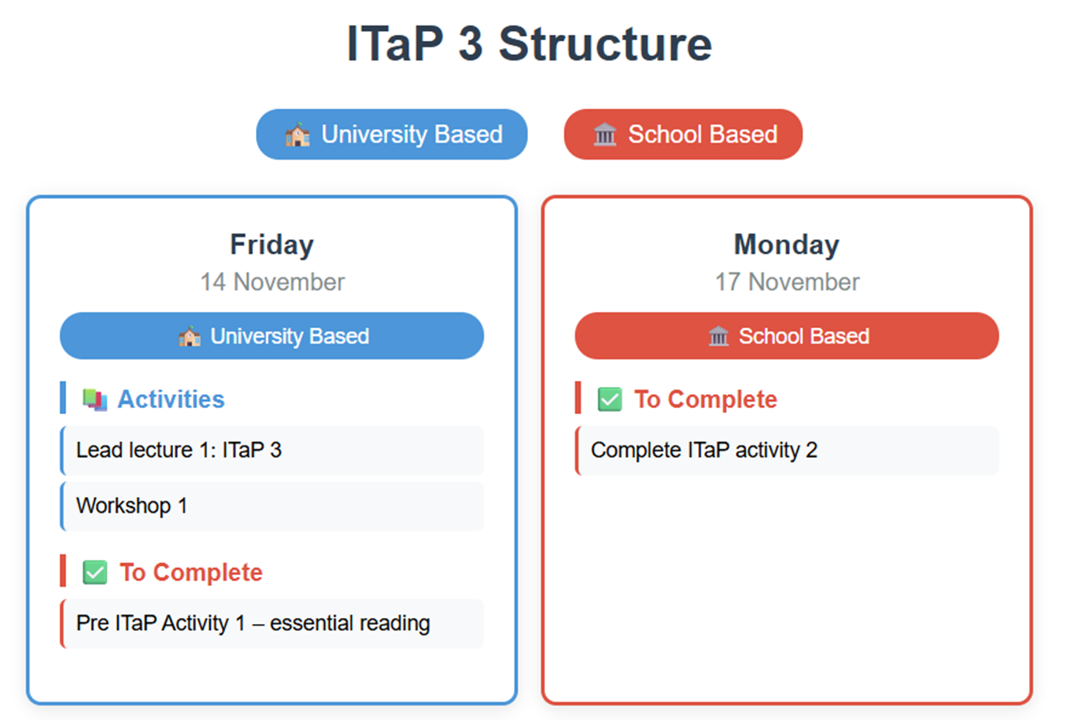
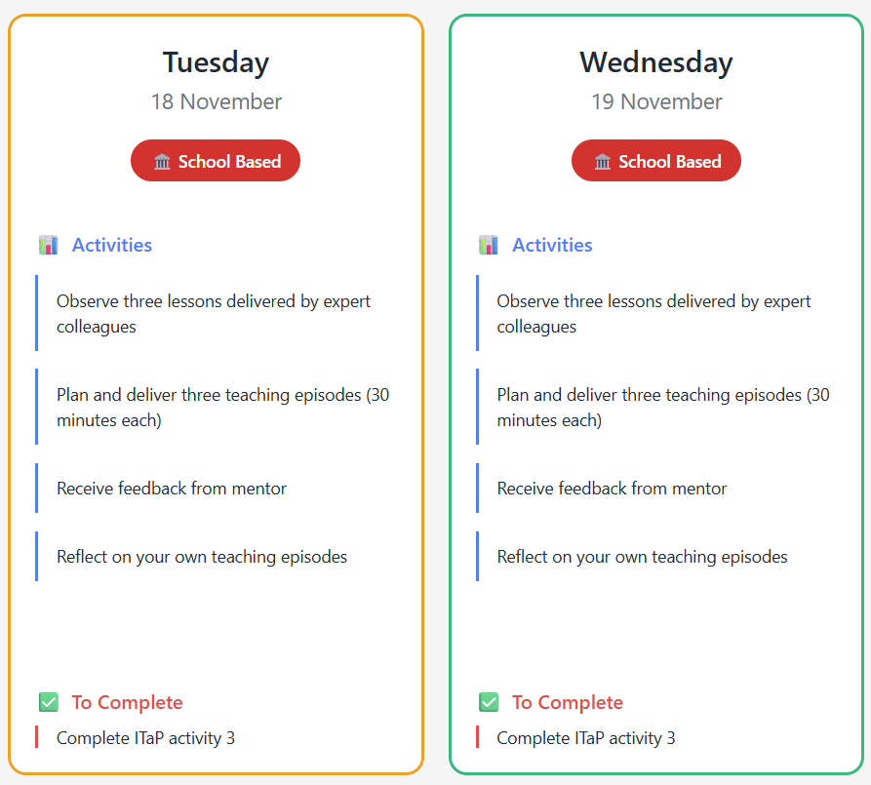

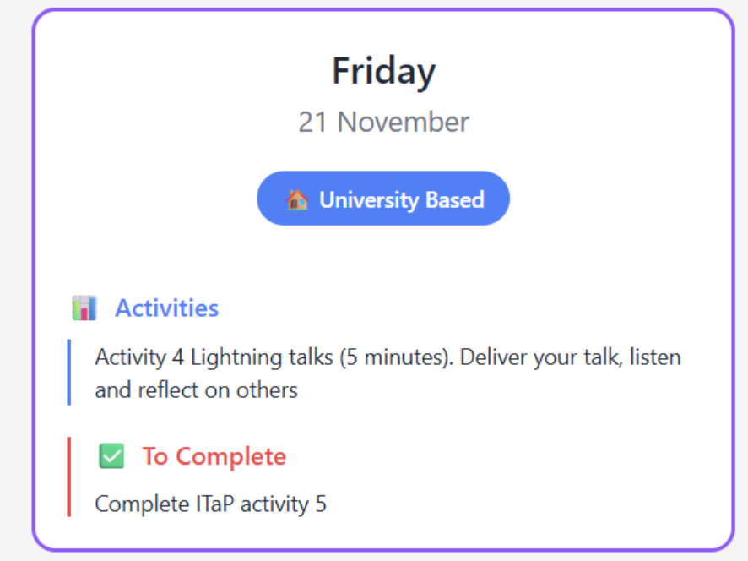
Activity 1 – Pre ITaP : Essential Reading (14/11/25).

Complete this during your Friday subject sessions at university.

Read Mandouit, L. and Hattie, J. (2023) ‘Revisiting “the power of feedback” from the perspective of the learner’, Learning and Instruction, 84, p. 101718. doi:10.1016/j.learninstruc.2022.101718.

Summarise the key messages of this article.

If you could ask the author two or three questions about effective feedback, what would they be?

Reflect on your own experiences of feedback from your days at school/college/uni. What did effective feedback look and feel like to you?

Reflect on instances during your placement where you observed or used effective feedback. Consider what made the feedback effective?

Activity 2 - Observing Expert Colleagues’ Effective Feedback (on placement, 17/11/25).

At university on Friday, 14 November, you were introduced to a range of feedback techniques:
- Feed up, feed back and feed forward
- Ensuring pupils receive and act on feedback
- Verbal vs written feedback
- Self-orientated, task written, task symbol, process, and self-regulation.

Today you will observe three different lessons. As you observe the teacher during the lesson look out for the feedback techniques. Please note when the experienced teacher you are observing feeds back to pupils in other ways that are effective.

You will then be required to reflect on how the feedback influences progress and motivation in the grid below. In the table below identify the times when effective feedback was the main purpose of the observation. Note the strategies the teacher used, how often they used them and to what effect.
Teacher  initials | Practical Strategies – practical strategies identified in observation, for example use of live marking. | Effect – the impact on learning that you observed.

Activity 3 – Teaching, feedback, and reflection (Tuesday and Wednesday 18/11/25 and 19/11/25).

Over Days 3 and 4 of the ITAP, you will deliver a teaching episode to three different classes. You will agree a suitable length for each teaching episode with your mentor, though 30 minutes is suggested.

You will be expected to plan each activity with an emphasis on feedback to pupils. This may be verbal, written, formal, informal; whole class, individual, group, corrective, celebratory; spontaneous, recorded in books, worksheets or digitally.

Before delivering each activity, please share the planning document with an expert colleague to enable them to write a little feedback.

You will use the document provided over the next three pages to plan and reflect on these teaching episodes.

Teaching Episode 1

Planning your 30-minute teaching episode
Outline the concepts and teaching methods you will use. Focus on the feedback that you will give to pupils. Refer to key ITAP techniques like high quality instruction, well-timed feedback, developing self-regulation, ensuring that pupils act on feedback.

Mentor feedback
This section is for your mentor, or other expert colleague. Please provide your comments on the student teacher’s use of feedback during the lesson.

Student teacher reflection
In which parts of the lesson was the feedback most effective? What challenges did you observe or experience? What were the best examples of effective feedback that you observed? What might you do differently in your teaching next time?

Teaching Episode 2
Planning your 30-minute teaching episode
Outline the concepts and teaching methods you will use. Focus on the feedback that you give to pupils. Refer to key ITAP techniques like high quality instruction, well-timed feedback, developing self-regulation, ensuring that pupils act on feedback.

Mentor feedback
This section is for your mentor, or other expert colleague. Please provide your comments on the student teacher’s use of feedback during the lesson.

Student teacher reflection
In which parts of the lesson was the feedback most effective? What challenges did you observe or experience? What were the best examples of effective feedback that you observed? What might you do differently in your teaching next time?

Teaching Episode 3
Planning your 30-minute teaching episode
Outline the concepts and teaching methods you will use. Focus on the feedback that you give to pupils. Refer to key ITAP techniques like high quality instruction, well-timed feedback, developing self-regulation, ensuring that pupils act on feedback.

Mentor feedback
This section is for your mentor, or other expert colleague. Please provide your comments on the student teacher’s use of feedback during the lesson.

Student teacher reflection
Student teacher reflection
In which parts of the lesson was the feedback most effective? What challenges did you observe or experience? What were the best examples of effective feedback that you observed? What might you do differently in your teaching next time?

ITaP Activity 4 – Lightning talks (at university, 21/11/25).

You will deliver a short lightning talk to your fellow student teachers. This is not only an opportunity for you to make sense of your own experience and hear from others, but it also helps you develop your practice and presentation skills.

Please follow the instructions below:
- Prepare a 5-minute talk (no longer than 5 minutes). Use only the ‘prompt notes’ on the next page.
- No PowerPoint slides – this will be a spoken presentation only.
- You will stand up and present to the group.
What to include in your talk:
- What has been your most important learning about feedback during the ITaP?
- Can you describe a specific challenging moment or “critical incident” you observed or experienced?
- How did you handle the situation, what was effective, and what might you change if it happened again?
- In what ways has this experience shaped how you plan to approach pupil feedback when you return to placement?

While listening to other students’ talks, reflect on the following:
- What new insights about pupil feedback did you gain?
- How did the speaker handle challenges, and what might you do similarly or differently?
- How were the speaker’s experiences similar to or different from your own?
- What questions would you like to ask the speaker about their experience?

Prompt notes for your lightning talk

ITaP Activity 5 – Case study re-visited (at university, 21/11/25)
Looking forward: Thinking about what you have read, observed and practised, what are the most important three or four things you have learnt about effective feedback?

As you move through Phase 3, what targets do you think you should set yourself related to effective feedback? What do you think these targets will help you to achieve? Please be specific.

